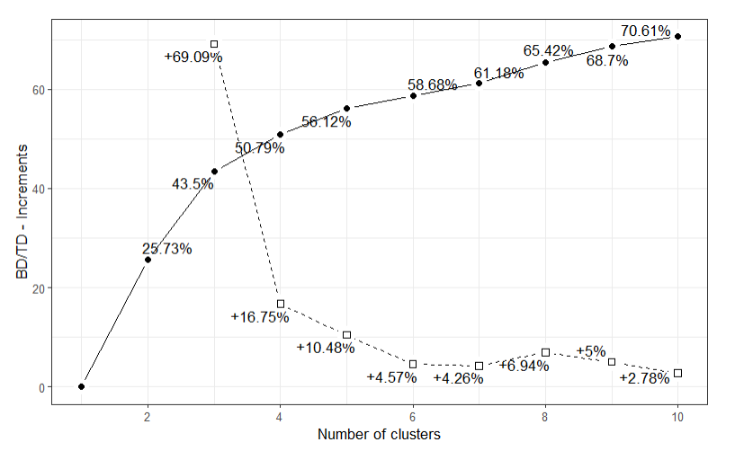
I chose the optimal clusters being 8. I made this decision because there is an uptick in the interpretability at 8 of 3% and goes back down after that. Also, we are looking to create new roles so we need to have more than the standard 5 roles.

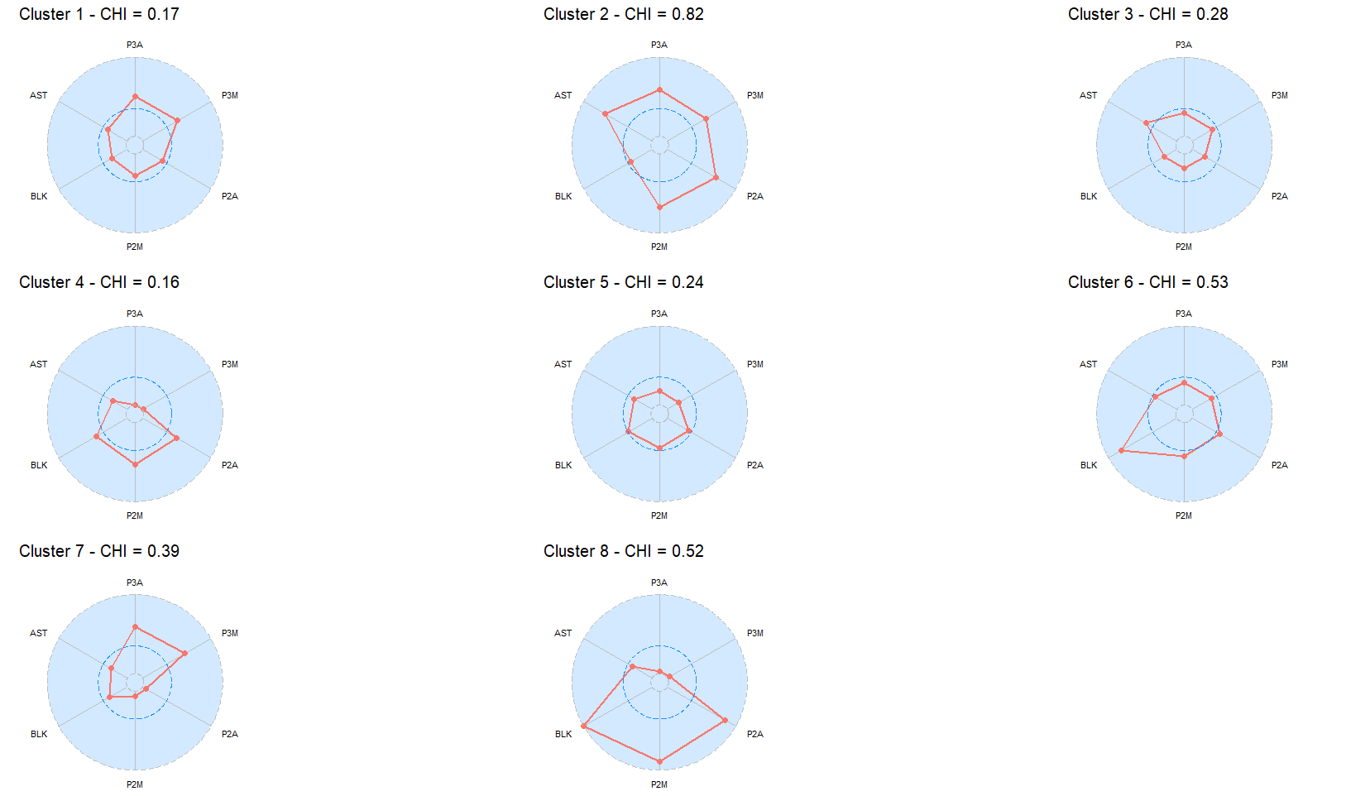
For starters the Chi value for clusters 2, 6, and 8 is above 0.5 so we must take that into account in our interpretation as it undermines their values. Cluster 1 represents players that shoot more 3PTs than 2PTs, but still shoot an average amount of 2PTs. Cluster 2 represents players that move that ball around and take a variety of shots. Cluster 3 represents players that don’t shoot very often and move the ball to the open many for the shot. Cluster 4 represents players that focus on 2PT shooting and blocks, most likely backup big man. Cluster 5 represents players that are average to below average in all areas, most likely bench players. Cluster 6 represents players that focus on blocks and less on offense, more of a defensive specialist. Cluster 7 represents players that focus on 3PT shooting, like a 3PT specialist. Cluster 8 is a more exaggerated for of Cluster 4 very heavy 2PT shooting and Blocks, starting big man.

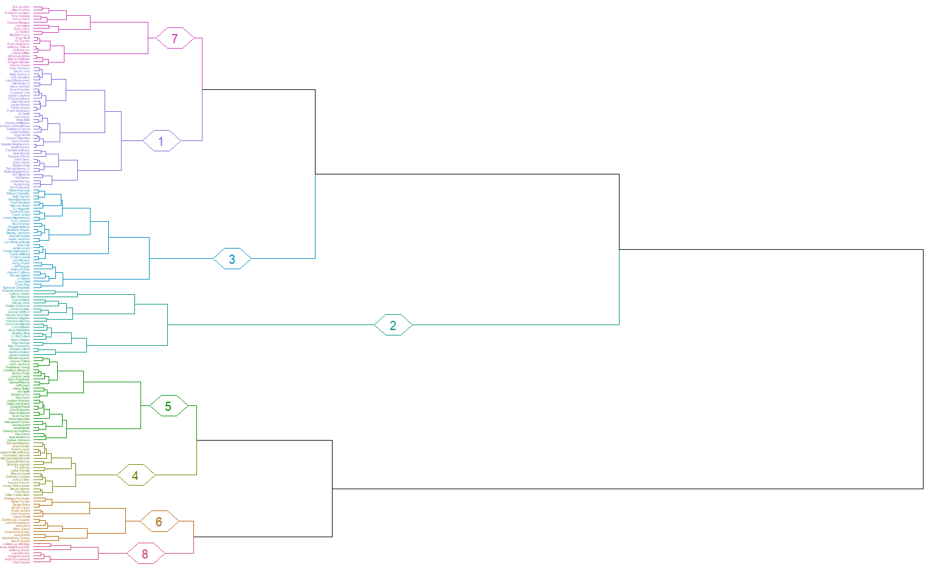
I think it is interesting how similar Clusters 6 and 8 are to each other. It is as if they are the same position but Cluster 8 is the players that are elite in that position. They both appear to be the smallest clusters and the closest to each other. In Cluster 8 there are players like Giannis and AD which I think of as big lanky players that play defense well and are offensive threats but not 3PT shooters.

